Senior Research Fellow

Position Description
Employment Type: Full-time or Part-time (minimum 3 days per week)
Term: Fixed-term contract, 3 years with 6-month probation
Location: Office space available in Box Hill, Victoria. Open to interstate researchers working remotely and working from Box Hill office approximately 12 days per annum.
Reports To: Dr Di Winkler, CEO
Purpose: The role of the Senior Research Fellow is to contribute to the research and dissemination activities of the Summer Foundation Research Unit.
Position Summary
A Senior Research Fellow is expected to carry out independent and/or team research within the relevant field and carry out activities to develop their research expertise relevant to the particular field of research.

Responsibilities & Duties
- Conduct and publish, or otherwise disseminate high quality and/or high impact research as a member of a team or independently and produce conference/seminar papers and publications from that research;
- Lead and/or contribute to writing up research findings for publication and dissemination;
- Prepare research proposal submissions to external funding sources;
- Engage with industry and community to ensure that all research results are communicated and adopted by industry, community and/or government;
- Co-supervise or supervise Higher Degree by Research (HDR) postgraduate students as required;
- Mentor and build the capacity of other research team members;
- Supervise research support staff involved in the staff member's research;
- Develop limited amount of research related material for teaching or other purposes;
- Contribute to the development and maintenance of a robust and ambitious research culture;
- Contribute to the activities of the organisation, as agreed with manager and as consistent with the requirements of any external contracts relating to funding of the position;
- Attend to effective and efficient performance of allocated leadership and administrative functions primarily connected with the area of research;
- Pursue continuing professional development and foster culture of curiosity and learning in the research team;
- Contribute to building relationships at local and national level;
- Undertake other duties commensurate with the classification and scope of the position.

Skills & Experience

Essential Criteria

Completion of a PhD or equivalent qualifications and research experience in an area relevant to younger people in aged care (e.g. disability, housing, discharge planning or primary health). Qualifications in a range of disciplines will be considered (e.g., clinical psychology, neuropsychology, occupational therapy, physiotherapy, social work, speech pathology, epidemiology, disability studies, public health, urban planning or data science);

A record of publications, conference papers and/or reports, or professional or technical contributions which provide evidence of strong research potential;

Sound analytical skills with an ability to communicate complex information clearly both orally and in writing;

High level organisational skills: the ability to set priorities, meet deadlines, initiate and follow-up actions, all with minimal or no supervision;

Demonstrated ability to work collaboratively with people with severe acquired brain injury;

Demonstrated ability to work collaboratively and productively with staff and students from a diverse range of backgrounds;

Ability to liaise effectively with a range of collaborators nationally and/or internationally and with industry partners;

Evidence of the ability to work as a member of a team in a co-operative and collegial manner;

Demonstrated high level of self-motivation and personal management skills;

Currently hold, or be able to obtain, a Working With Children Check;

Employment subject to National Police History Check.

Desirable Criteria
- Experience in the preparation of research proposal submissions to external funding bodies and evidence of success in securing research funding;
- Confident and competent user of technology;
- Drivers licence and own vehicle.

Core Competencies
The successful applicant’s values will match those of the Summer Foundation. The Summer Foundation’s values include:
Vision: We are creative, innovative and resourceful. We continually strive to be the best
Integrity: We act with integrity and honesty in everything we do
Communication: We communicate openly by exchanging information and actively listening to all stakeholders
Team Spirit: We value and recognize the contribution of our colleagues, both locally and globally. We enjoy working together to achieve outstanding results and total job satisfaction
Corporate Responsibility: We act responsibly within our community and care for the environment

Other Relevant Information
The position description is indicative of the initial expectation of the role and subject to changes to Summer Foundation goals and priorities, activities or focus of the job.
People with disability are encouraged to apply. Lived experience is valued by the organisation and looked upon favourably.

About the Summer Foundation
Established in 2006, the key aim of the Summer Foundation is to change human service policy and practice related to young people in nursing homes. The Summer Foundation utilises a range of strategies to influence health, housing, aged care and disability service policy and practice related to this target group.

The Summer Foundation’s five key strategies to preventing young people being forced to live in nursing homes are:
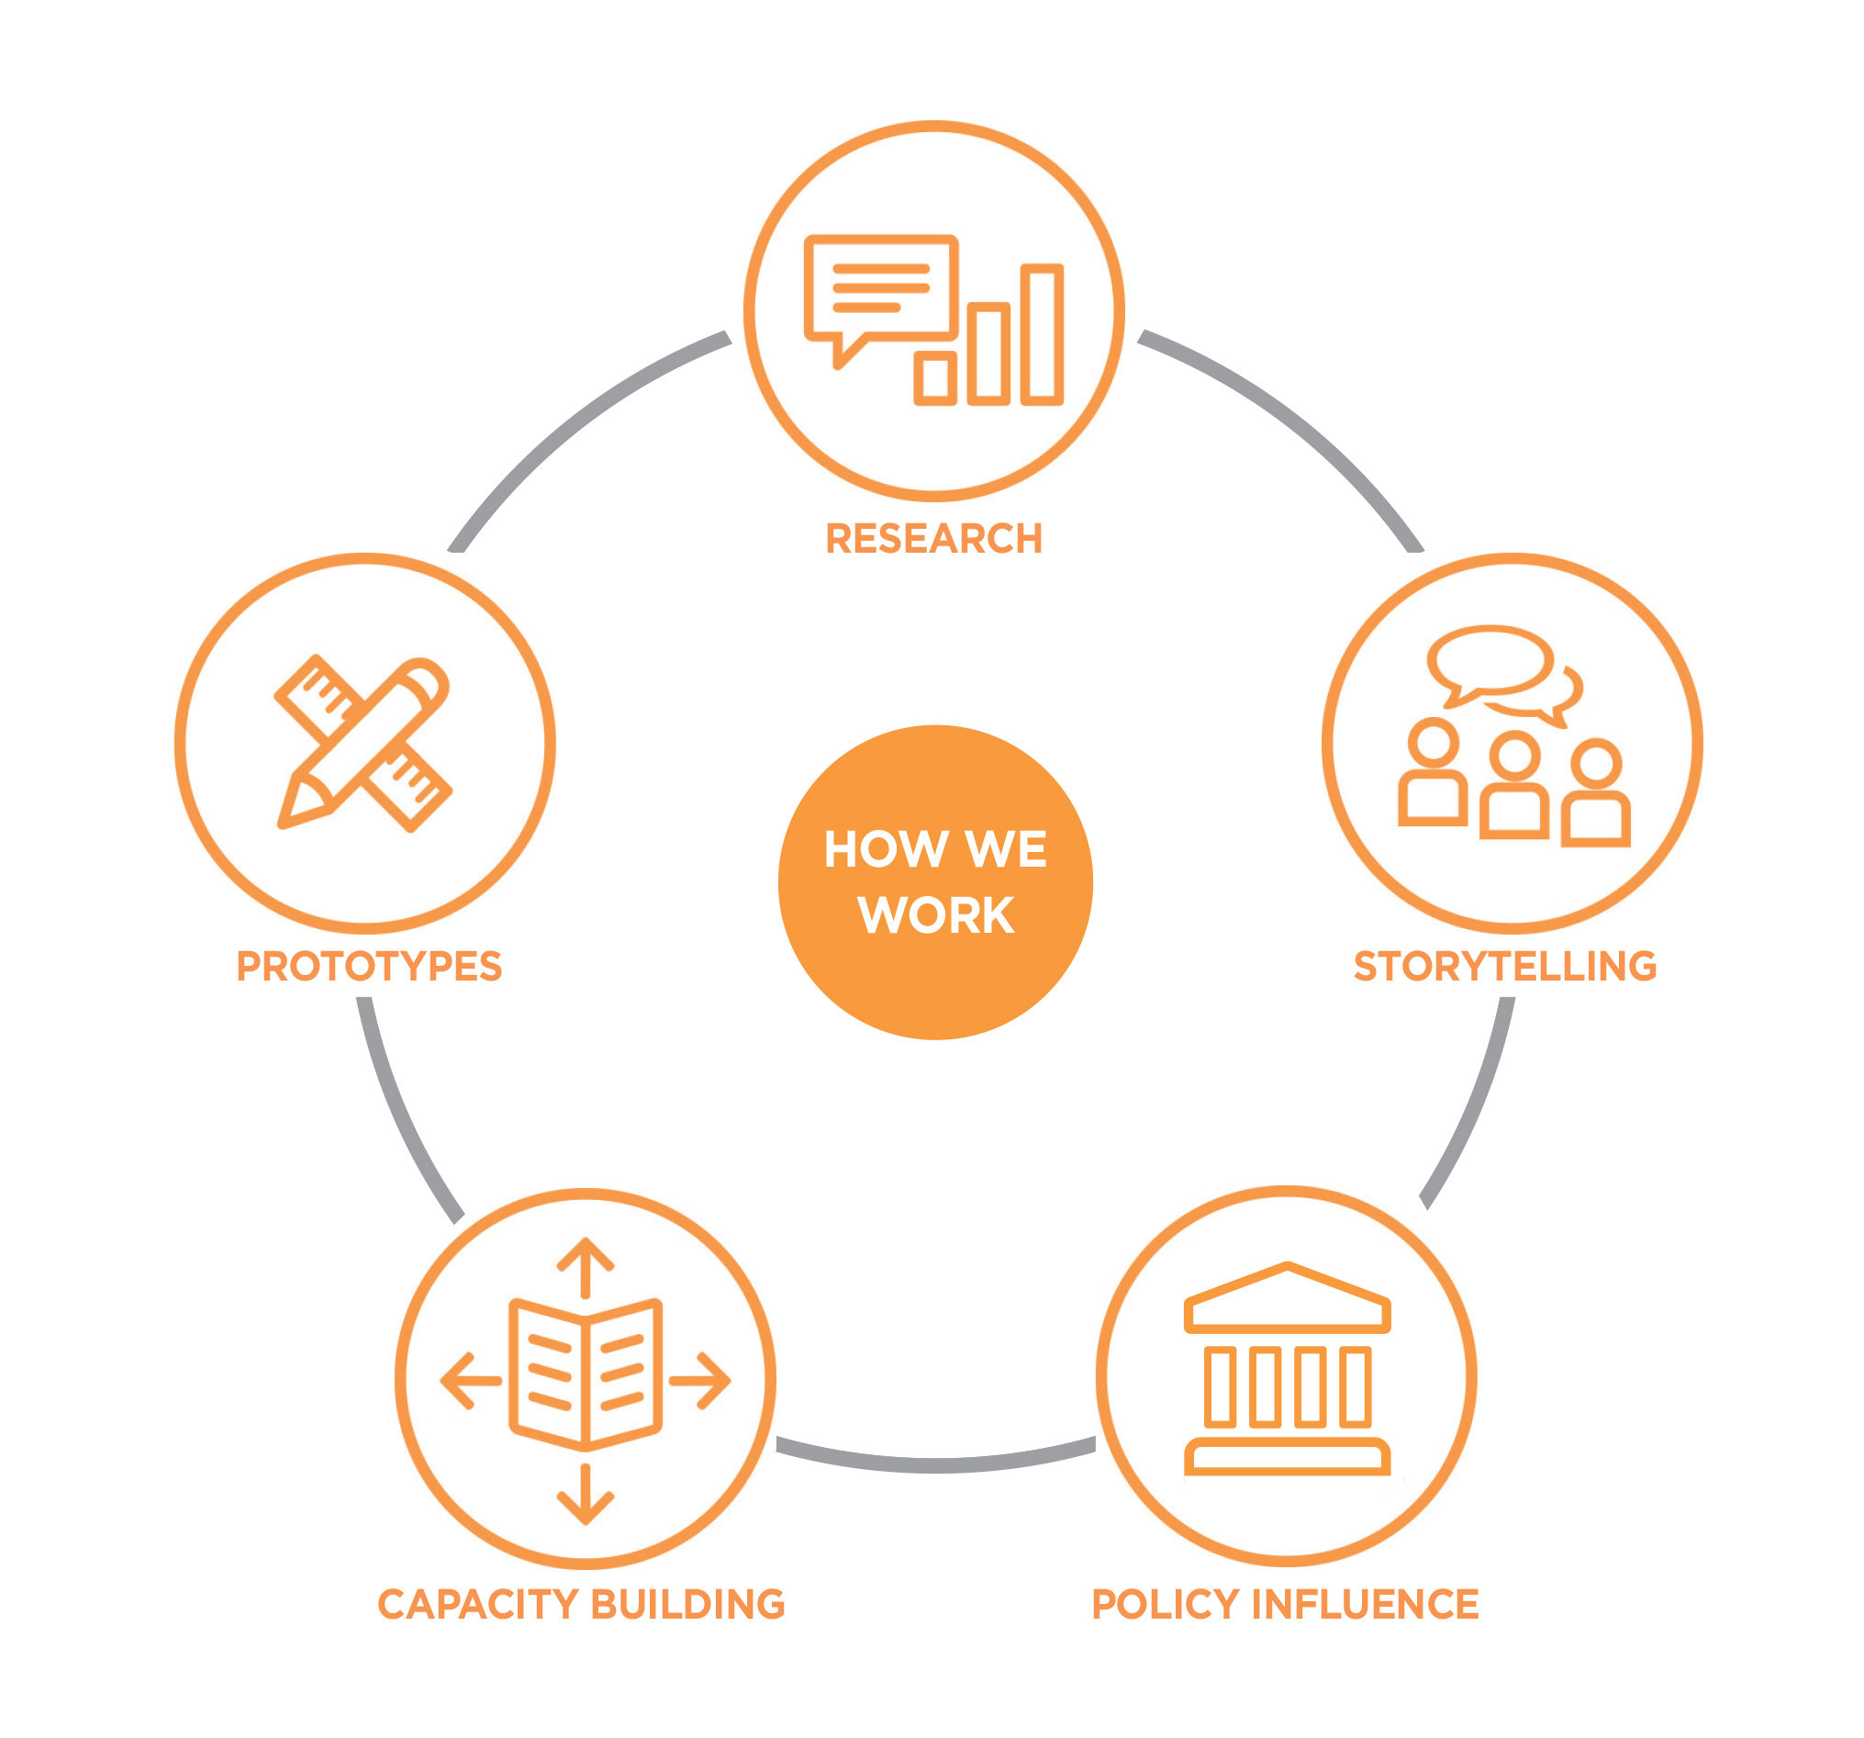

Research ~ Data collection and analysis to provide an evidence base for problem solving
Storytelling ~ Support people with lived experience to share their journeys and perspectives
Prototypes ~ Designing, testing and evaluating new solutions
Capacity Building ~ Share information and best practice with stakeholders
Policy Influence ~ Shape thinking and change decisions of governments

What policy change do we want?
There are four key areas that must be addressed to resolve the issue of young people in nursing homes in Australia.

- Those in RAC or at risk of RAC entry have NDIS plans which support and reflect their goals
- Significantly increase the volume and range of high quality, accessible and affordable housing
- Health, disability and other systems communicating and collaborating to support discharge to community living
- Define the challenges and explore solutions to barriers that limit access to primary and community health services

