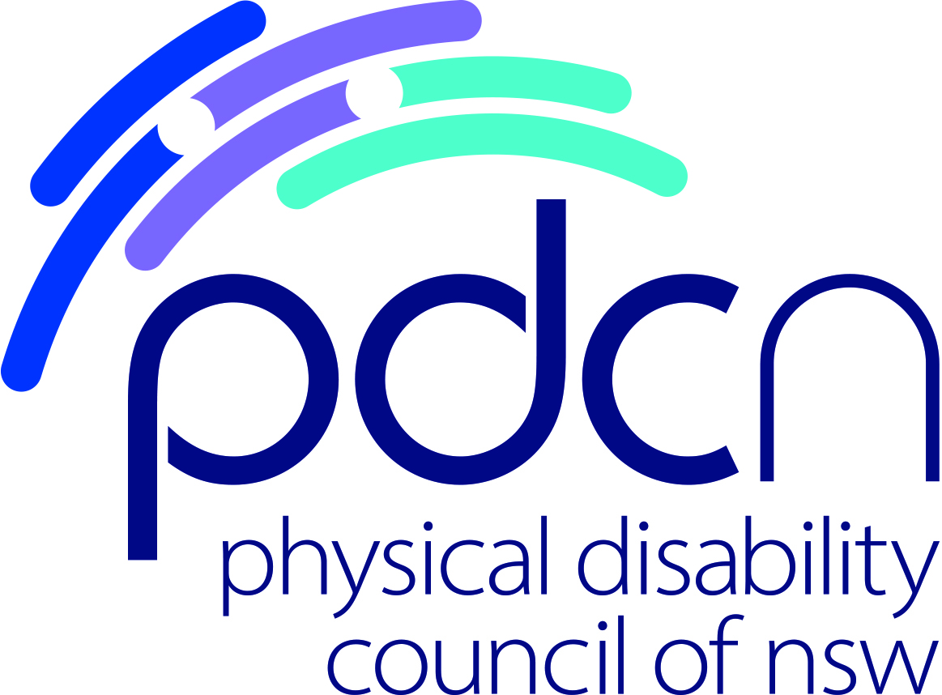

Position Title: Project Officer ILC Peer Project

Location: Glebe, NSW 2037
Hours: Full time 37.5hrs
36 month contract to end February 2023

Remuneration: SCHADS award Level 4, paypoint 1
Responsible to: Project Manager, ILC Peer Project

Organisation: Who is the Physical Disability Council of NSW?

The Physical Disability Council of NSW (PDCN) is the peak representative organisation, of and for, people with physical disability across New South Wales. The Council has a majority of people with physical disability in its membership, its governance (i.e. Board), and employees. It is also a not-for-profit, non-government organisation.

The objectives of the Physical Disability Council of NSW (PDCN) are:
- To educate, inform and assist people with physical disabilities in NSW about the range of services, structures and programs available that enable their full participation, equality of opportunity and equality of citizenship.
- To develop the capacity of people with physical disability in NSW to identify their own goals, and the confidence to develop a pathway to achieving their goals (i.e. self-advocate).
- To educate and inform stakeholders (i.e. about the needs of people with a physical disability) so they are able to achieve and maintain full participation, equality of opportunity and equality of citizenship.

Role Overview:
The NDIS ILC Peer Project Officer oversees administration of all areas of the funded ILC Peer project, providing operational support including the coordination of facilitators, venues, accommodation and travel arrangements, materials and resources, promotion of peer groups, workshops and peer mentoring sessions, and data input.

Duties and responsibilities:
- General administrative tasks associated with ILC Peer program and educational workshops including - locating and booking venues, supporting facilitators, organising catering and travel
- Assist in the promotion of peer groups and workshops
- Maintaining accurate enrolment and attendance records
- Data input of group and workshop feedback documentation
- Willingness and ability to travel if required
- Answer phone, online and email enquiries
- Other duties as identified by Project Manager

Essential criteria
- Excellent administration, organisational and time management skills
- Excellent oral and written communication skills
- Demonstrated customer service skills, and the ability to engage with a diverse range of people
- Attention to detail and strong problem solving skills
- Experience in using Microsoft Office suite
- Ability to work autonomously and as part of a team

Desirable criteria
- Experience working with people with disability and/or a lived experience with disability.
- Qualifications or experience in administration or office management
- Current NSW Driver’s Licence
- Ability to travel on occasion throughout NSW to support peer group and workshop facilitators

All Physical Disability Council of NSW employees are required to provide a Police Record Check and Working with Children Check on appointment (PDCN will reimburse cost of these checks).

PDCN Offers
- Flexible work environment and practices
- Supportive, friendly and collaborative team
- Attractive remuneration package, including salary sacrificing options and leave loading

Should you want to make a meaningful contribution to improving the lives of people with physical disabilities, and enabling full inclusion in the community, we invite you to apply.

Application Process:
Please send your Curriculum Vitae and cover letter responding to the essential and desirable criteria to wendy.banfield@pdcnsw.org.au

Applications Close: COB Friday 6 March, 2020

For further enquiries please contact:
Wendy Banfield – 02 9552 1606

