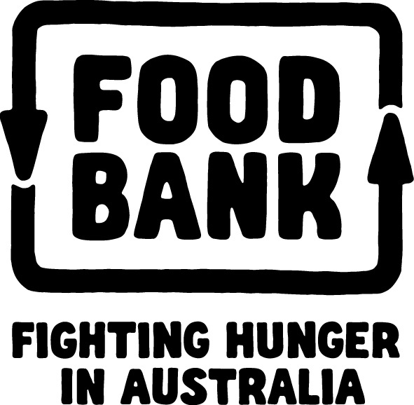

Position Description

Role: National Partnerships Executive (Maternity Leave Cover)
Reporting to: General Manager Strategic Partnerships
Reports: None
Location: Sydney

Position Overview:

Due to an upcoming maternity leave in the corporate partnerships team, Foodbank is seeking a Corporate Partnership Executive Reporting to the General Manager Strategic Partnerships. This role is responsible for offering account management services to current partners through administrative support of the department.

The role is ideal for an individual with a demonstrated experience of high level administrative skills and building strong and mutually beneficial relationships with other functions and organisations.

Responsibilities:
- Providing support for aspects of our partnerships, including work place giving, volunteering, grants, sponsorships, partner events and cause related marketing campaigns
- Support Foodbank partnerships team to achieve team KPIs
- Support General Manager Partnerships as required
- Work closely with Foodbank Marketing & Communications Manager on all partner marketing and communication needs
- Provide updates for all reporting requirements (weekly updates, Leadership Team and Board updates)
- Establish and maintain good relationships with wider Foodbank Marketing & Fundraising Team (within Foodbank State and Territory locations)
- Active participant of Foodbank’s Marketing & Fundraising Committee
- Contribute, along with other staff members, to the smooth running of the office by answering phones, maintaining contacts in Salesforce, assisting with basic office administration etc.

Capabilities & Behaviours:

Influences Outcomes
- Uses influencing skills in order to get things done.
- Builds behind-the-scenes support both internally and externally to ensure buy-in and ownership; gets stakeholders on side.
- Calculates the best/most appropriate way to gain buy-in, including removing self.

Plans and Coordinates
- Thinks through and produces a broad plan and detailed schedule to forecast the activities needed to deliver an objective.
- Clearly prioritises and schedules multiple, interrelated tasks which include management of complex variables and issues.
- Focuses on monitoring performance of self, including personal KPIs.
- Proactively seeks and implements more effective use of resources.

Inspires Leadership
- Translates broader strategy into meaningful strategy for own area.
- Combines clarity of purpose with personal conviction and a sense of determination to be the best.
- Always demonstrates enthusiasm and commitment to work and to developing others in the function. Good role model that espouses positive energy.

Succeeds through Collaboration
- Takes a broad organisational view at all times; gives priority to activities that benefit the organisation as a whole over ‘quick wins’ for own area.
- Brings conflict within the team into the open and drives for resolution of differences.
- Consistently plans for and considers interpendencies with internal operational areas.

Builds Effective Relationships
- Prospects the external environment to identify key sector or potential partner contacts.
- Maintains consistent and regular contact with a wide network of internal and external contacts to create future opportunities.
- Consistent team player; shows respect for other team members and proactively offers their support, always puts the common team goal and organisational goals before individual goals.
- Genuinely passionate and engaged in their own work and the work of others, consistently displays a positive energy and confidence about work which motivates others.

Skills & Expertise:
- Relevant degree or reasonable practical experience in fundraising or the for-purpose sector
- Understanding of food industry is beneficial (but not essential)
- Knowledge and experience in delivering administrative systems and processes
- Highly professional and articulate with the ability to develop and maintain relationships
- Exception written skills and attention to detail
- Ability to work autonomously and be a team player
- Understanding of brand and cause related marketing is desirable
- Have experience writing proposals and presentations
- Feel confident with your ability to make supporters feel valued and nurtured

Required
- Microsoft Word, Outlook, PowerPoint, Excel
- Effective, strong communication expertise (both written and oral)
- Negotiation and relationship management experience

Optional
- Driver’s license
- WordPress
- Salesforce
- Photoshop
- Publisher

Expected Outcomes
3 months
- Demonstrates a good understanding of Foodbank:
- overall fundraising and partnerships strategy
- existing corporate and co-promotion partnerships including agreements, commitments, reporting obligations etc.
- Met and established relationships with key external stakeholders
- Good working relationship with relevant State & Territory Foodbank contacts
- National grants calendar in place and opportunities being actively identified

12 months
- Active team member contributing to the delivery of Foodbank’s annual plan
- Successfully implemented new partnerships delivering additional contributions to Foodbank’s fundraising income
- Contributing to fundraising forecasts and future fundraising strategy
- Made material improvements to administrative processes (reporting, CRM, volunteering etc)

