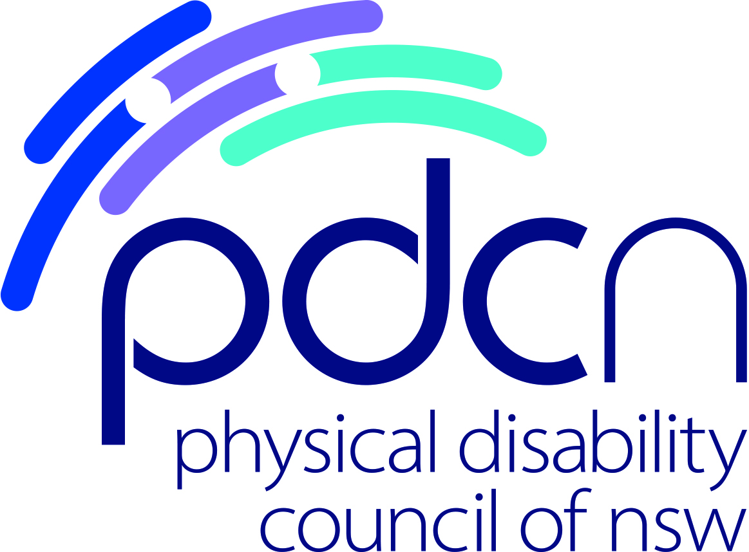

Position Title: Peer Facilitator and Mentor

Location: Glebe

Hours: 30hrs per week (4 days)
36 month contract to end February 2023

Remuneration: SCHADS Level 5, paypoint 1
Responsible to: Project Manager, ILC Peer Project

Organisation: Who is the Physical Disability Council of NSW?

The Physical Disability Council of NSW (PDCN) is the peak representative organisation, of and for, people with physical disability across New South Wales. The Council has a majority of people with physical disability in its membership, its governance (i.e. Board), and employees. It is also a not-for-profit, non-government organisation.

The objectives of the Physical Disability Council of NSW (PDCN) are:
- To educate, inform and assist people with physical disabilities in NSW about the range of services, structures and programs available that enable their full participation, equality of opportunity and equality of citizenship.
- To develop the capacity of people with physical disability in NSW to identify their own goals, and the confidence to develop a pathway to achieving their goals (i.e. self-advocate).
- To educate and inform stakeholders (i.e. about the needs of people with a physical disability) so they are able to achieve and maintain full participation, equality of opportunity and equality of citizenship.

Project Overview:

The Physical Disability Council of NSW (PDCN) has secured Information, Linkages and Capacity Building (ILC) funding under the National Disability Insurance Scheme (NDIS) to deliver peer support groups, individual peer mentoring and a suite of workshops for people with disability and their families for a period of three years, until February 2023.

PDCN peer support groups aim to build member’s individual capacity, increase social interaction, and offer a space where peers can safely share personal experiences and knowledge to empower and educate each other.

Individual mentoring involves working one to one with a person with disability (or family member) to achieve an identified goal.

Workshops delivered in this project will include NDIS specific topics, resilience building and advocating and communicating one’s rights.

Duties and responsibilities
- Bring together and support people with disability and/or their families into local community peer groups
- Lead monthly peer group meetings, including sharing information, facilitating group conversation and building rapport
- Successfully recognise, capture and record individual and group achievements to provide feedback to group members, PDCN and project funders
- Facilitate educational workshops
- Provide one to one mentoring
- General administrative tasks (calling and emailing group members, writing meeting minutes and attendance lists, assisting group members to fill out membership forms and surveys)
- Communicate regularly with the Project Manager to provide updates, feedback and necessary paperwork in a timely manner
- Lead monthly online leadership meeting

Essential Criteria
- Identify as a person with a physical disability
- Experience in interacting with other people with disability
- Experience of person centered approaches and inclusion
- Experience in facilitating workshops or small groups
- Cert IV in Training and Assessment (or willingness to undertake – PDCN will pay for training)
- Confidence to work in a range of different environments
- Ability to work autonomously and as part of a team
- Computer literacy (Microsoft Office and capacity to use cloud based software)
- Ability to travel on occasion throughout NSW to lead various local peer group activities / workshops

Desirable Criteria
- Mentoring experience (formal or informal)
- Knowledge of the National Disability Insurance Scheme (NDIS) or willingness to learn

All Physical Disability Council of NSW employees are required to provide a Police Record Check and Working with Children Check on appointment (PDCN will reimburse cost of these checks).

PDCN Offers
- Flexible work environment and practices
- Supportive, friendly and collaborative team
- Attractive remuneration package, including salary sacrificing options and leave loading

Should you want to make a meaningful contribution to improving the lives of people with physical disabilities, and enabling full inclusion in the community, we invite you to apply.

Application Process:
Please send your current Curriculum Vitae and a cover letter which briefly addresses the essential and desirable criteria to wendy.banfield@pdcnsw.org.au

Application closing date: COB Friday 28 February, 2020

For further enquiries please contact:
Wendy Banfield – 02 9552 1606.

