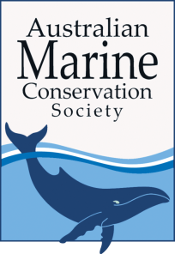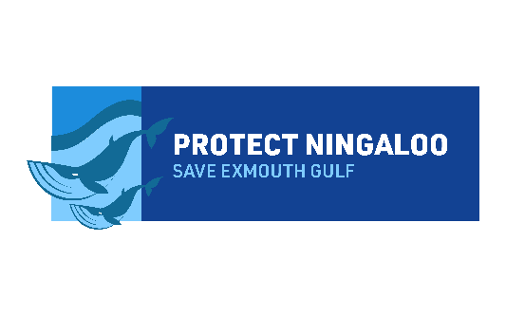

Position Description

Position Communications Advisor
Hours Full-time (38 hours per week)
Reports to Director, Protect Ningaloo Campaign
Location of position Perth
Contract period Two years with possibility for extension.
Remuneration A competitive NGO salary for a suitably qualified candidate.
Position Summary:
The Protect Ningaloo Campaign aims to protect the Ningaloo-Exmouth Gulf region from the threat of industrialisation and bolster its conservation. For this to occur, we need a high-performing campaign team that is passionate, dedicated and committed to achieving results. We are seeking an experienced communications professional to rapidly build the profile of the Protect Ningaloo Campaign as part of a major new development phase.

This is an exciting role if you are passionate about conservation and protecting our oceans and special places like Ningaloo-Exmouth Gulf. Join a great team and make a real difference as you work to defend our marine life and natural heritage.

The Protect Ningaloo Campaign is an initiative of the Australian Marine Conservation Society (the host), the Conservation Council of WA and the Cape Conservation Group (Exmouth).
We are looking for a dynamic, professional communications Advisor with exceptional digital communications and media skills to join the team and help us protect Ningaloo – Exmouth Gulf.

Purpose of position:
This exciting new role will draw on a suite of communications skills. It is focussed on managing Protect Ningaloo’s digital channels, media outreach and digital supporter communications, as well as managing day-to-day relationships with communications agencies and media buyers.
You will work with the Director and other colleagues to coordinate and implement the communications strategy with a strong focus on digital communications - including supporter engagement - and traditional media.

Your background in digital communications and media will help you to analyse the effectiveness of the campaign’s communications approaches to rapidly enhance Protect Ningaloo’s profile in target markets and to build its supporter base.

Your experience with media liaison and relationship management will assist you in working with the team to develop compelling stories and pitches to media, delivering a higher profile for Protect Ningaloo in a competitive media space.

Main tasks and responsibilities:

- Communications Strategy Coordination and Implementation
- Coordinate the development and implementation of an effective communications strategy, working closely with the Director and team.
- Coordinate briefs for communications agencies and media buyers to deliver key components of the communications strategy, acting as key liaison with agencies.
- Oversee the management of contracts and budgets with communications agencies.
- Develop messaging guides and fact banks in collaboration with the campaign team.

- Digital Communications and Evaluation
- Develop and manage digital communications and marketing campaigns to build the campaign’s profile and influence.
- Manage the digital campaign social media channels (website, Facebook, Twitter, Instagram), and provide guidance on content development and use.
- Oversee, manage and deliver regular and timely EDMs for supporters, working with the campaign team on content.
- Analyse, report on and refine the campaign’s digital effectiveness.
- Review new and emerging technologies that can enhance the campaign.

- Media
- Drive and support messaging development, including overseeing message testing and research as needed.
- Coordinate drafting of media releases/alerts.
- Pitch stories to journalists and actively build relationships in the media sector.
- Monitor media daily and provide regular feedback and analysis to inform reactive and proactive stances.

- Website
- Manage the Protect Ningaloo website and devise strategies to drive online traffic to it.
- Devise and implement strategies to drive and grow calls-to-action, from on- and offline platforms.
- Manage the campaign website and core digital communications/marketing budgets.

- Other Activities
- Provide communications support for other campaign activities including events, and production of communications materials.
- Deliver regular, cogent communications activity reports for key campaign stakeholders.

Essential Selection Criteria:
- Demonstrated experience in management and development of social media channels.
- Demonstrated experience using web tools and digital marketing for supporter growth, engagement and activation, including via email marketing campaigns.
- Demonstrated experience in media liaison, with ability to conceive strong story ideas and write compelling media releases/briefs.
- Excellent project management skills, as demonstrated through, for example, managing a project with an agency from concept to execution, evaluation and improvement.
- Excellent communication skills with demonstrated ability to write great web and supporter communications content.
- A track record of working effectively as part of a small, dynamic team.
Desirable Selection Criteria:
- Commitment to and knowledge of ocean conservation.
- Experience in a similar role in an advocacy organisation.
- Relevant degree or qualification in communications, digital media, marketing or a related field.
- Strong, active networks in media and communications sectors in WA and nationally.
- Experience using web content management systems.
- Multimedia design skills including graphic design and video production.
- Experience in campaigning.

Application details
Applications are required by COB (WST) Monday, 21 October 2019.
Applications should be submitted by email to recruitment@amcs.org.au with the subject: Communications Advisor, and must include a statement (maximum two pages) addressing the essential selection criteria, a covering letter and resume of previous employment experience.
For more information about the position please submit your query via recruitment@amcs.org.au
AMCS (Protect Ningaloo host) is a strictly non-partisan and equal opportunities employer. Indigenous Australians are encouraged to apply. Applicants must have the right to work in Australia.

