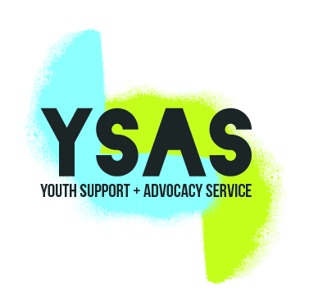

APPLICATION FORM
Please email completed application form to careers@ysas.org.au
Name:
Email address:
Name of role you are applying for: | Vocational Specialist Worker
What website did you find this job?

I’ve attached my recent CV in Word or PDF form ☐
I am an Australian Citizen or Permanent Resident ☐

Key Selection Criteria
For us to understand your skills and capability, we have introduced a Key Selection Criteria (KSC) assessment. This information will be used to assess your skills and experience against the key components of the role you are applying for.

As a guide, you can use the STAR technique to answer the KSC. For your reference, the STAR acronym has been provided for you.
Situation – Tell us about the situation
Task – Tell us what was involved
Action – Tell us what actions you undertook
Result – Tell us what happened as a result of your actions
Try to use a different scenario for each KSC as this will provide a broader insight into your background and increase your chances to progress to the interview stage.

KEY SELECTION CRITERIA
Highly developed engagement and communication skills with young people experiencing multiple and complex social disadvantage.

Answer to Key Selection Criteria

Advanced skills in engaging and supporting the young people to overcome vocational and non-vocational barriers to employment and education and comprehensive knowledge of this service system.

Answer to Key Selection Criteria
Answer to Key Selection Criteria

Evidence of development, implementation and evaluation of youth health, mental health, vocational support or wellbeing program
Answer to Key Selection Criteria

Demonstrated ability to negotiate and advocate for individual clients (and/or their families) with external agencies

Answer to Key Selection Criteria

Highly developed interpersonal, and communication skills, including sound oral and writing skills; and practical knowledge of and familiarity with computer applications;

Answer to Key Selection Criteria

Ability to contribute to a multi-disciplinary team and to establish effective relationships with staff, clients, carers and workers in community agencies;

