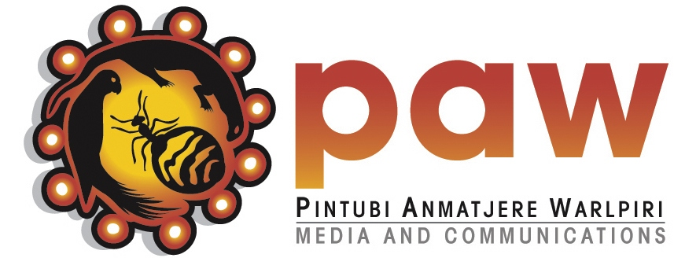
Warlpiri Media Aboriginal Corporation
ICN 8336 ABN 65 345 684 535
(trading as PAW Media and Communications)
LPO Yuendumu, via Alice Springs, NT 0872
Ph 08 8993 7500 Fax 08 8956 4100

POSITION DESCRIPTION

TITLE indigiMOB Digital Support Worker
RESPONSIBLE TO General Manager
POSITION BASED Yuendumu.
SALARY $67,184 + Superannuation.

inDigiMOB digital support workers increase digital inclusion in remote communities by improving digital awareness and digital literacy; supporting local digital mentors; and creating relevant learning resources.

They do this by supporting and delivering activities, workshops and projects that improve digital skills and knowledge so remote community residents can take full advantage of digital and communication technologies and shape their digital futures.

Digital support workers also work with mentors and other community members to create ‘How-To’ resources. These might be videos, photo books, audio stories, fact sheets and animations. Once created, these resources can become part of the inDigiMOB Online App and reach even more people.

Digital support workers support digital mentors to work alongside them in projects and workshops and become the go-to technology experts in their communities.

As well as delivering activities and workshops directly, digital support workers identify opportunities for workshops by specialist trainers.

Duties of inDigiMOB Digital Support Worker:

- Provide engaging and inclusive workshops that aim to develop digital literacy skills.
- Provide access to and supervision of facilities for delivery of digital workshops.
- Identify, train and assist digital mentors.
- Provide accessible and current information around ICT services and assist with troubleshooting.
- Report on activities both daily and monthly and collect feedback
- Provide workshops, digital support and training in other communities as part of the outreach strategy.
- Set up and maintain an inviting, creative and engaging Cultural Centre in consultation with community members to access Keeping Culture.
- Provide accessible and inclusive training for community members in Keeping Culture and archive related projects.
- Keep uploads to archives regular and allow for community members to contribute their own collections.
- Train digital mentors to assist with Keeping Culture training.
- When necessary support other PAW Media activities which may include video, radio, music production, and community events.

